To begin our 30 day challenge we need a sample database to work with in our MySql Server
I am assuming that you have already installed and set up MySql on your computer. If not then go ahead and do so.

So the first thing we need to do is to set up our sample database known as world.
The world database is a sample database provided on the official MySQl website and gives developers a sample dataset to practice their SQL knowledge on. You can read more about it here ( https://dev.mysql.com/doc/world-setup/en/world-setup-preface.html )

I have the provided the world.sql file and all you have to do is copy/cut it into your sql projects/practice folder. If you don’t have such a folder , go ahead and create one.

1.Next , you Connect to the MySQL server using the mysql command-line client with the following command: mysql -u root -p

Enter your password when prompted. If you are using a non-root account , make sure that the account you have used has privileges to create new databases.

2. Next after successfully logging into your MySQL client in the terminal, Execute the world.sql script to create the database structure and insert the data using the following command:
mysql> SOURCE C:/temp/world.sql;
Replace the path to the world.sql file with the actual path on your system.

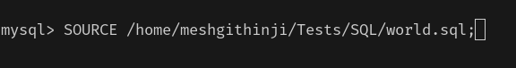
For example on my Linux machine the command looked like this:
confirm the path to your world.sql file

Note : On Windows, use slashes rather than backslashes when executing the SOURCE command.

3. To confirm that the sample world database is installed correctly, execute the following statements.
First switch to the world database by executing this command : USE world;
Now you are in the world database.
Next , Do the SHOW TABLES; command you should have 3 tables city , country and countrylanguage
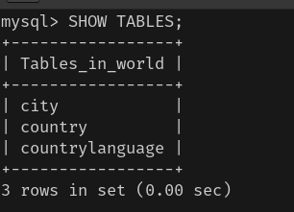

Next ,execute the following command : SELECT COUNT(*) FROM city;
You should get a similar output to the one below:
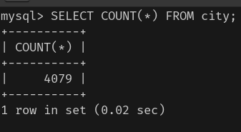

Next execute : SELECT COUNT(*) FROM country;
You should get a similar output to the one below:
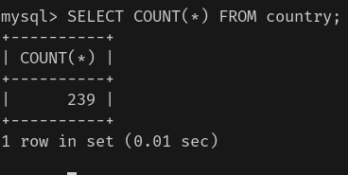

If you have gotten similar output to the ones in the images then You now have the world sample database installed.
Now we have a sample database we can use to practice our SQL.

